

**Faculty of Engineering and Technology**

**Electrical and Computer Engineering Department**

**Communication Lab - ENEE4113**

**Prelab for experiment (1)**

**Student’s Name: Ansam Osama**

**Student’s ID: 1201127**

**Section :** 3

**Instructor: Dr. Qadri Mayyala**

**Instructor**  **Assistant : Hazem Awaysah**

Contents

**1.** **Theoretical Prelab:** 4

**2.** **Software Prelab (LabVIEW (Simulink) ):** 6

**Block Simulation (MATLAB Simulink)** 6

**Modulated signal normal AM** 7

**Demodulation:** 13

**Envelop detection** 17

**demodulation** 17

**Table of Figures**

Figure 1:message and carrier signal parameter 7

Figure 2:: Normal AM Block 8

Figure 3:spectrum of m(t) 8

Figure 4:spectrum of c(t) 9

Figure 5:Time domain representation of Am modulation when μ <1 10

Figure 6:frequency 10

Figure 7:time domain 11

Figure 8:frequency 12

Figure 9:time 13

Figure 10:frequency 13

Figure 11:Coherent Demodulation 14

Figure 12:Time domain representation of Coherent Demodulation when μ <1 15

Figure 13:Frequency domain representation of Coherent Demodulation when μ <1 15

Figure 14:Time domain representation of Coherent Demodulation when μ =1 16

Figure 15:Frequency domain representation of Coherent Demodulation when μ =1 16

Figure 16:Frequency domain representation of Coherent Demodulation when μ >1 17

Figure 17:Envelop detection demodulation 18

Figure 18:Time domain representation of Envelop detection Demodulation when μ <1 19

Figure 19:Frequency domain representation of Envelop detection Demodulation when μ <1 19

Figure 20:Time domain representation of Envelop detection Demodulation when μ =1 20

Figure 21: Frequency domain representation of Coherent Demodulation when μ =1 20

Figure 22Time domain representation of Envelop detection Demodulation when μ >1 21

Figure 23:Frequency domain representation of Coherent Demodulation when μ >1 22

# **Theoretical Prelab:**

**Review the theoretical background of the Normal Amplitude Modulation and Demodulation (Please give a detailed view on the mathematical (equations) side).**

The mathematical representation of an AM signal can be given as:

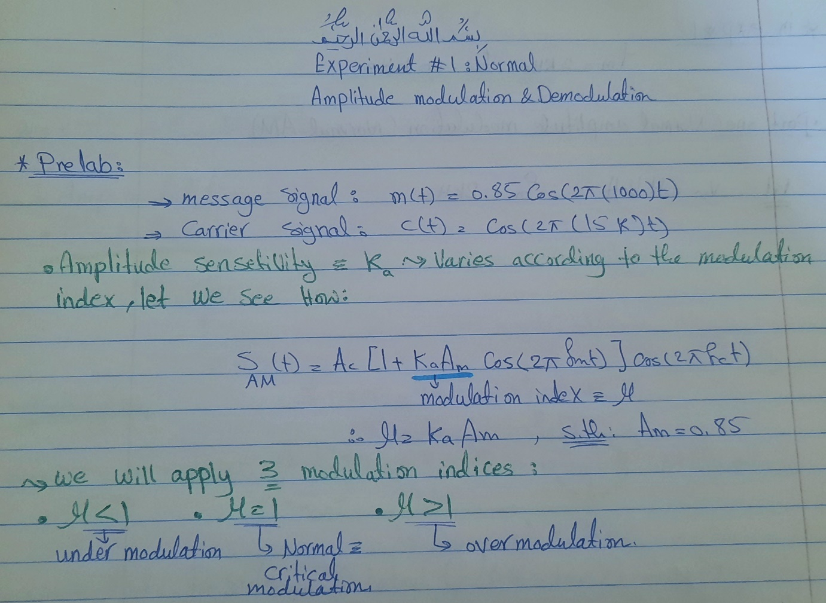

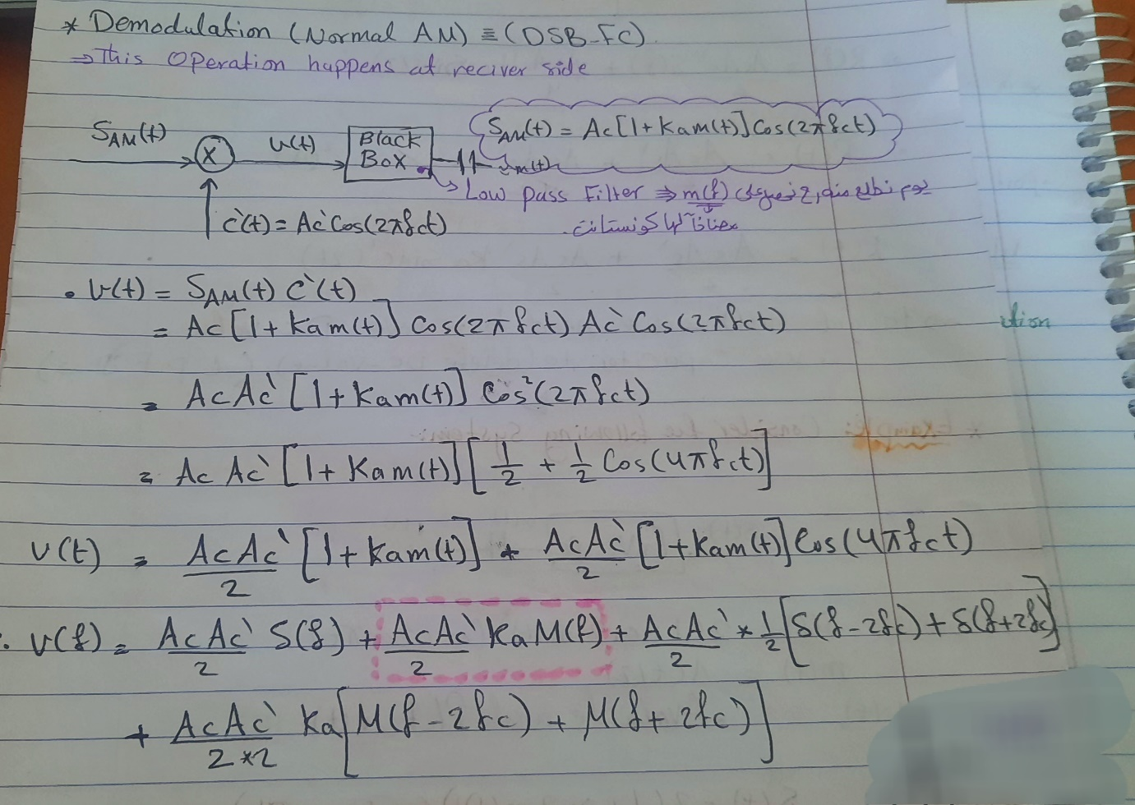

# **Software Prelab (LabVIEW (Simulink) ):**

Build a full simulation block diagram of the modulation and the demodulation of the Normal AM that shows both the time and frequency domains.

The diagram must show (message, carrier, modulated and demodulated) signals. Use two demodulation methods (coherent and envelope detector). Take into consideration to run your diagram for 3 modulation indices (μ<1, μ=1, μ>1 ). Show the parameters you have used in each block.

Message signal: 𝑚(𝑡) = 0.85cos(2𝜋(1000)𝑡)

Carrier signal: 𝑐(𝑡) = 1cos(2𝜋(15𝑘)𝑡)

## **Block Simulation (MATLAB Simulink)**

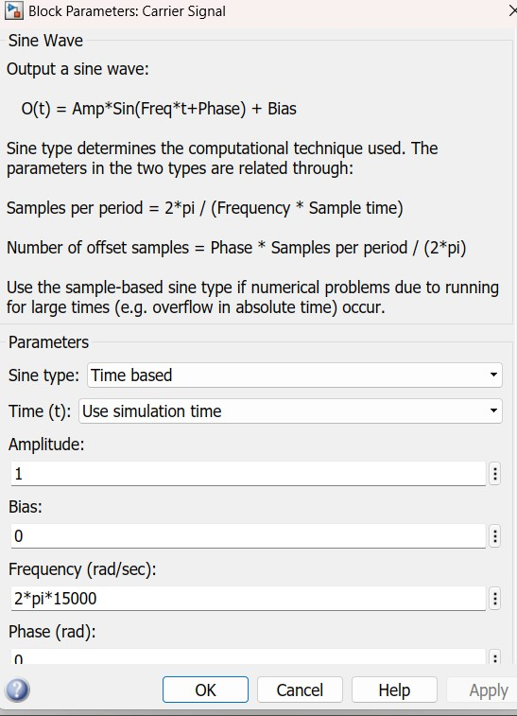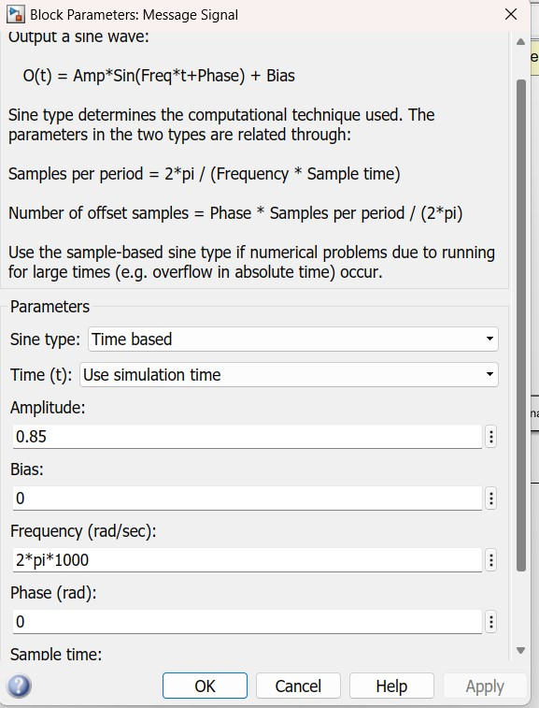

Figure 1:message and carrier signal parameter

# **Modulated signal normal AM**

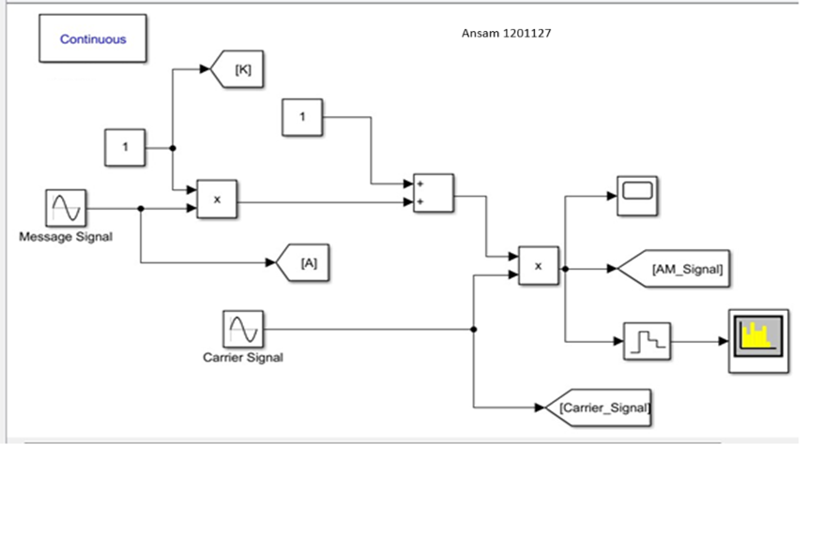

Figure 2:: Normal AM Block

𝑚(𝑡) = 0.8cos(2𝜋(1000)𝑡).

Spectrum of m(t) = 0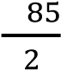.  δ(𝑓 − 1000)+ 0.  δ(𝑓 + 1000)

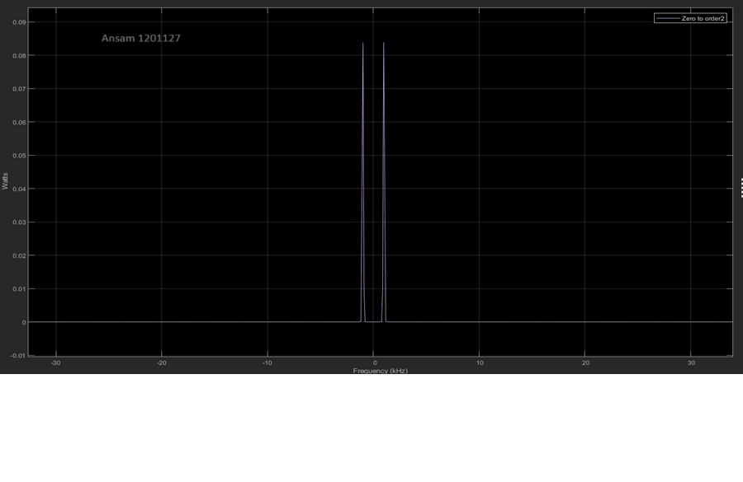

Figure 3:spectrum of m(t)

Carrier signal : 𝑐(𝑡) = 1cos(2𝜋(15𝑘)𝑡)

Spectrum of c(t) =  δ(𝑓 − 15000)+  δ(𝑓 + 15000)

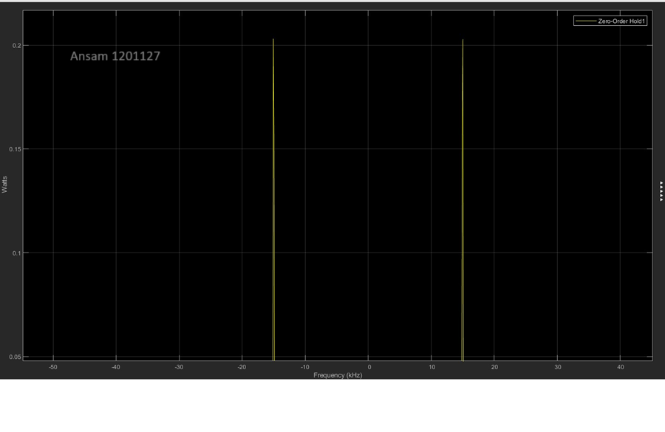

Figure 4:spectrum of c(t)

➢ When **(μ<1)** normal modulation: Ka = 0.5, Am = 0.85 , μ=0.425 Time Domain:

* The mathematical representation of an AM signal in time domain:

s(t) = Ac (1+ka m(t)) cos(2πfc t).

= (1) (1+ μ *cos(2𝜋(1000)𝑡 )) cos(2𝜋(15𝑘)𝑡)

* The mathematical representation of an AM signal in frequency domain :

S(f) =  [ δ(f− 15k) + δ(f+ 15k)] + ( 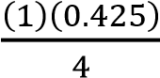 ) [ δ(f− (16000 ) + δ(f + (16000 )]

+( 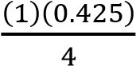 ) [ δ(f− (14000 ) + δ(f + (14000) )]

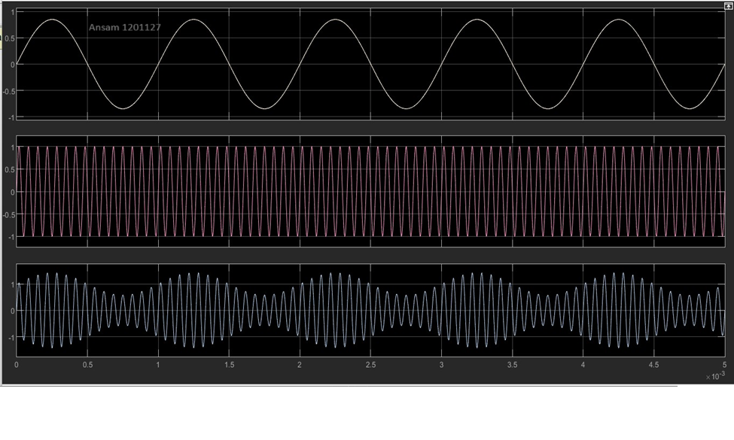

Figure 5:Time domain representation of Am modulation when μ <1

In frequency

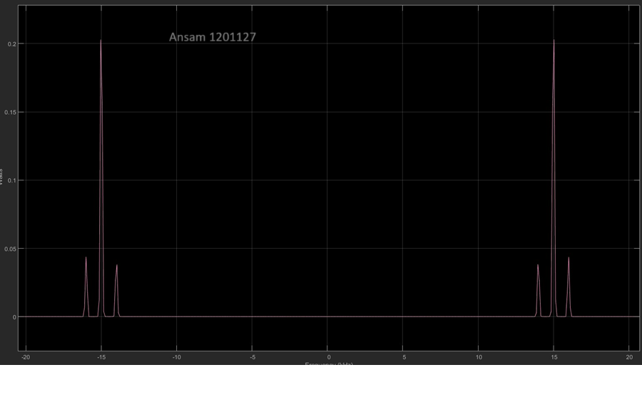

Figure 6:frequency

**For (μ=1) :**

Calculating the value of ka μ = ka . Am

ka = ( μ ) / (Am) = ( 1 ) / (0.85) = 1.1765

The mathematical representation of an AM signal in time domain:

s(t)= Ac (1+ka m(t))cos(2πfc t). = (1) (1+ 1.1765 ( 0.85cos(2𝜋(1000)𝑡 )) cos(2𝜋(15𝑘)𝑡)

The mathematical representation of an AM signal in frequency domain :

S(f) = (Ac) /2 [ δ(f− fc) + δ(f+ fc)] + ( (Ac) (μ) /4 ) [ δ(f− (fc + fm ) + δ(f + (fc + fm ) )] + ( (Ac) (μ) /4 ) [ δ(f− (fc - fm ) + δ(f + (fc - fm ) )]

= (1) /2 [ δ(f− 15k) + δ(f+ 15k)] + ( (1) (1) /4 ) [ δ(f− (16000 ) + δ(f + (16000) )] + ( (1) (1) /4 ) [ δ(f− (14000 ) + δ(f + (14000) )]

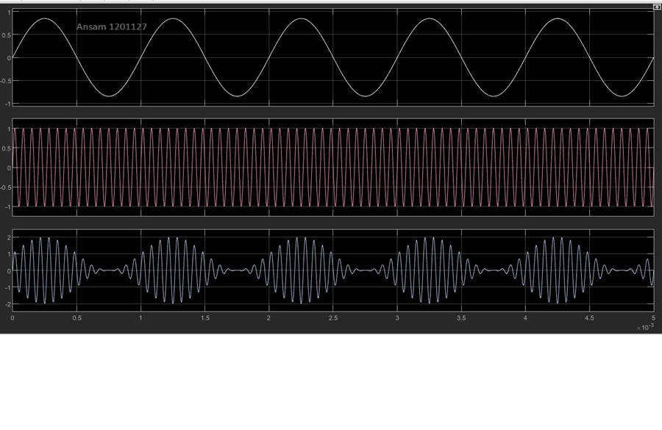

Figure 7:time domain

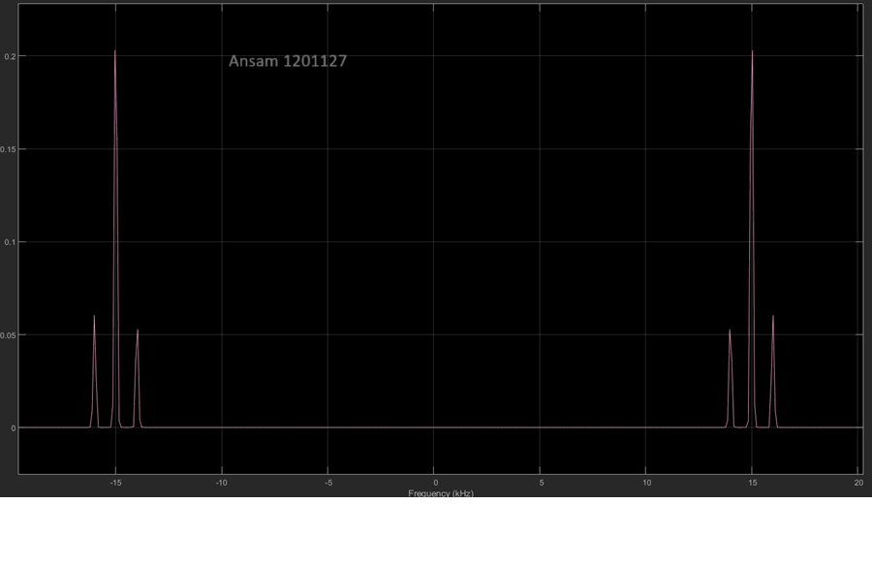

Figure 8:frequency

**When (μ>1): Ka = 2, Am = 0.85 , μ = 1.7**

The mathematical representation of an AM signal in time domain:

s(t) = Ac (1+ka m(t)) cos(2πfc t).

= (1) (1+ μ *cos(2𝜋(1000)𝑡 )) cos(2𝜋(15𝑘)𝑡)

The mathematical representation of an AM signal in frequency domain :

S(f) = 𝐴𝑐 [ δ(f− fc) + δ(f+ fc)]

2

+ ( (𝐴𝑐)(𝜇) ) [ δ(f− (fc + fm ) + δ(f + (fc + fm ) )] 4

+ ( (𝐴𝑐)(𝜇) ) [ δ(f− (fc - fm ) + δ(f + (fc - fm ) )]

4

S(f) =  [ δ(f− 15k) + δ(f+ 15k)] + ( 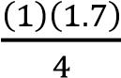 ) [ δ(f− (16000 ) + δ(f + (16000 )]

+( 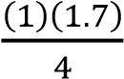 ) [ δ(f− (14000 ) + δ(f + (14000) )]

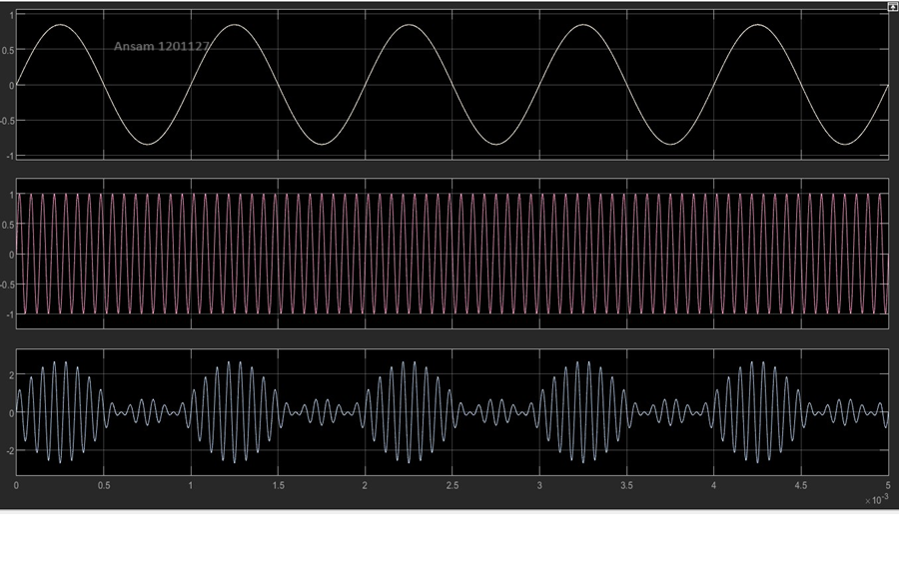

Figure 9:time

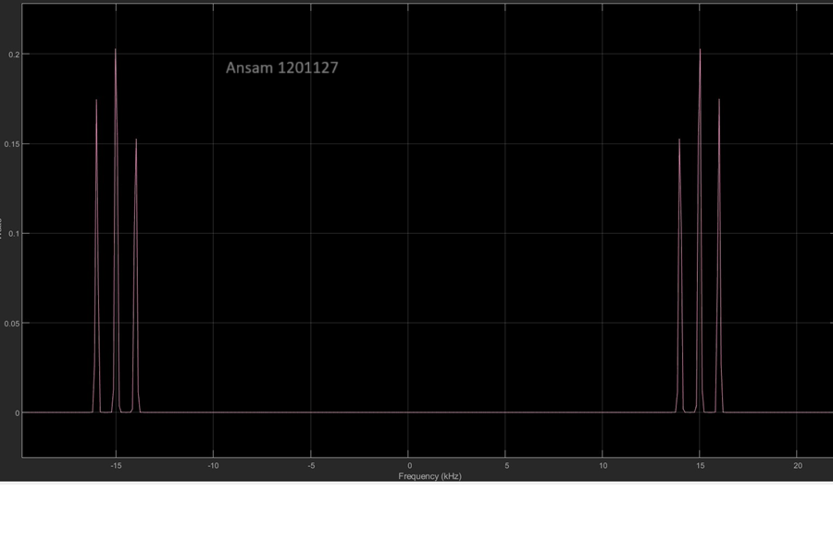

Figure 10:frequency

# **Demodulation:**



1- Coherent Demodulation

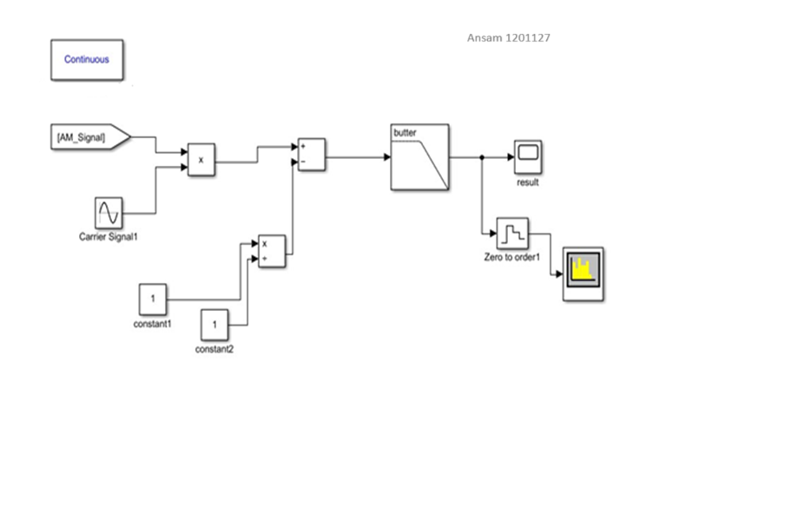

Figure 11:Coherent Demodulation

S’(t)= c(t) * s(t).

S’(t) =( cos ( 2pi (15 k ) t) ) ( cos ( 2pi (15 k ) t) + 0.5 cos ( 2pi (16k ) t) + 0.5 cos ( 2pi (14k ) t))

=0.5 cos ( 2pi (30k ) t) + 0.5 cos (0) + 0.25 cos ( 2pi (31k ) t) + 0.25 cos ( 2pi (1k ) t) + 0.25 cos

( 2pi (29k ) t) + 0.25 cos ( 2pi (1k ) t)

* M’(t) in time and frequency domain, when ka = 1, under demodulation Time Domain:

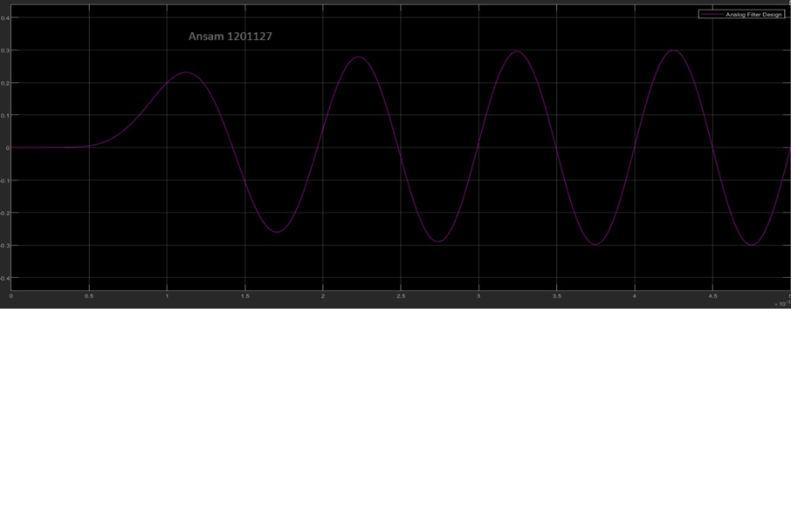

Figure 12:Time domain representation of Coherent Demodulation when μ <1

Frequency Domain Representation:

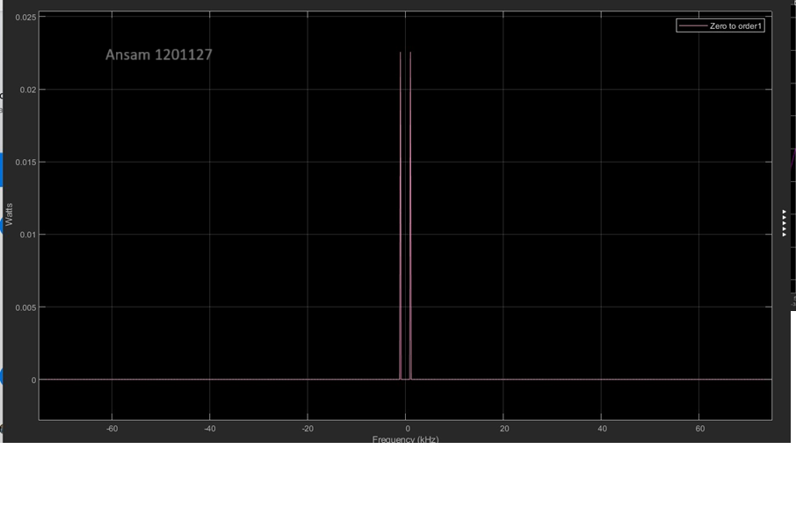

Figure 13:Frequency domain representation of Coherent Demodulation when μ <1

* When (μ = 1): Ka = , Am= 0.85

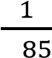0.

Time Domain

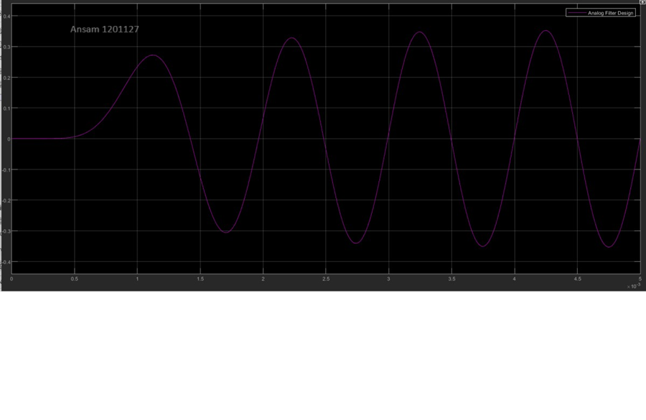

Figure 14:Time domain representation of Coherent Demodulation when μ =1

Frequency Domain Representation:

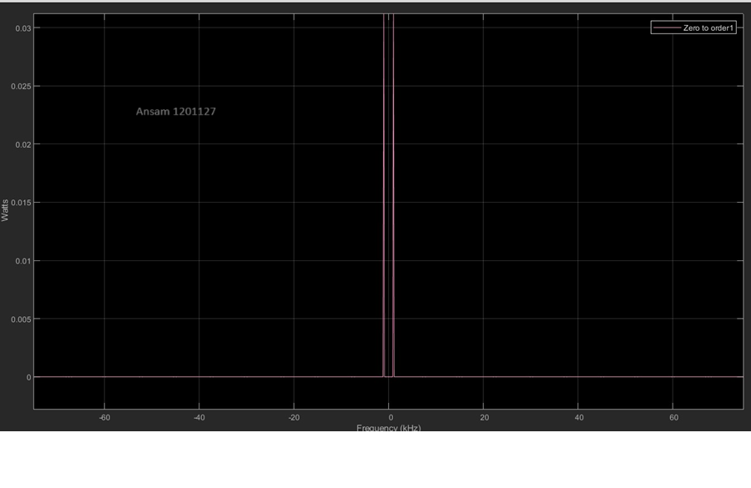

Figure 15:Frequency domain representation of Coherent Demodulation when μ =1

* When (μ>1), time domain: Ka = 2, Am = 0.85 Time Domain:

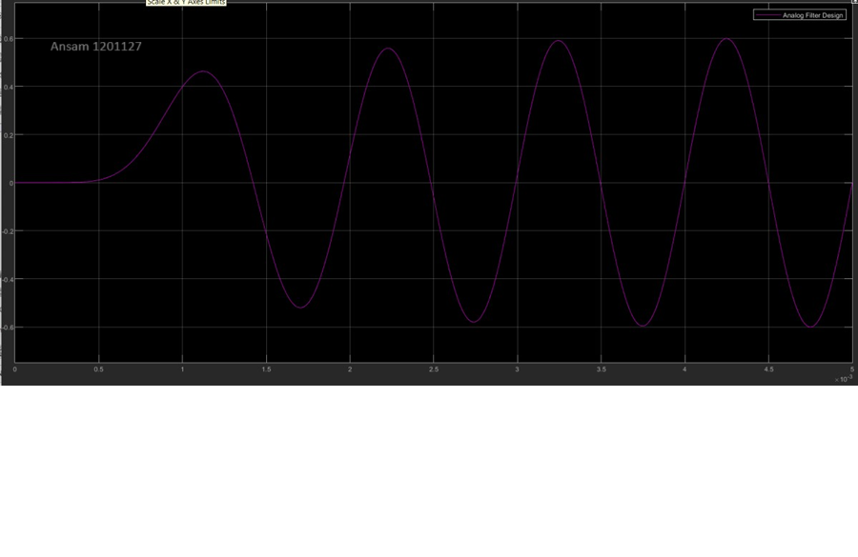

*Figure 17: Time domain representation of Coherent Demodulation when μ >1*

Frequency Domain Representation:

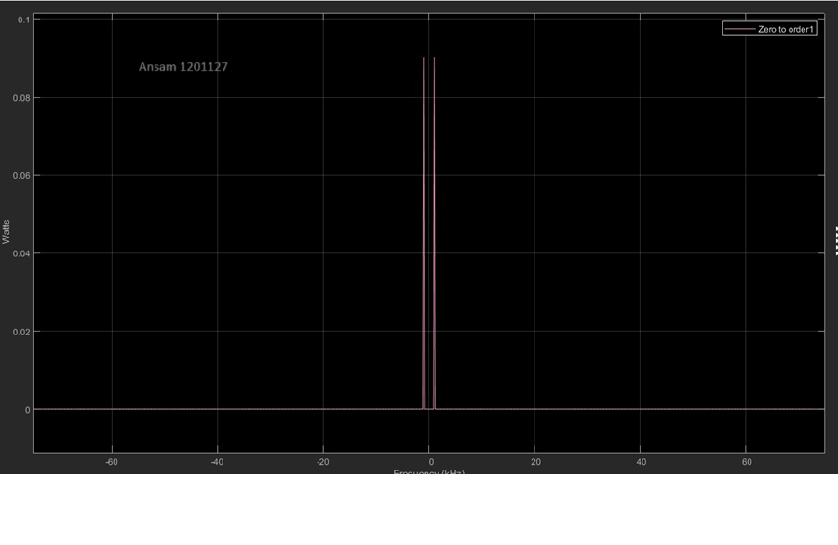

Figure 16:Frequency domain representation of Coherent Demodulation when μ >1

We see in figures apove he output of the demodulation process is equal to the message signal . that’s mean that we get the message signal after demodulation.

# **Envelop detection**

# **demodulation**

Block diagram:

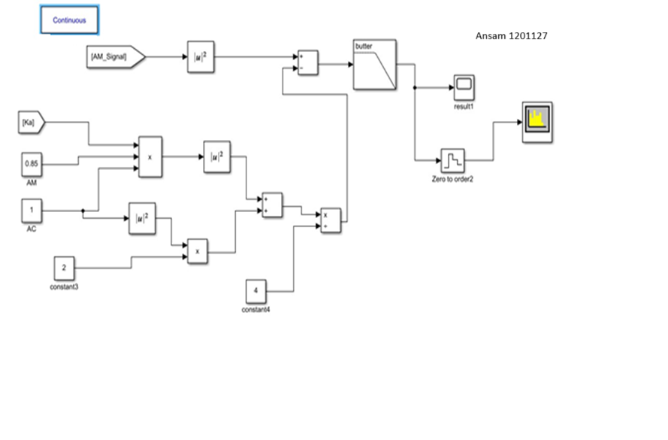

Figure 17:Envelop detection demodulation

M’(t) in time domain when ka=1 and μ <1 under demodulationTime Domain:

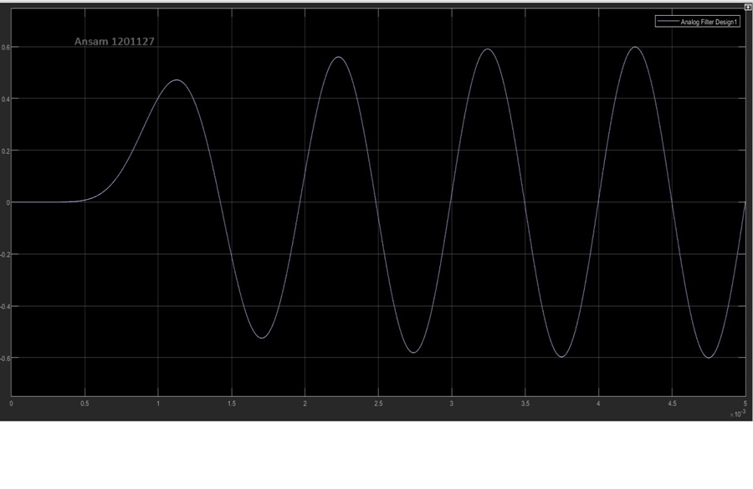

Figure 18:Time domain representation of Envelop detection Demodulation when μ <1

Frequency Domain Representation:

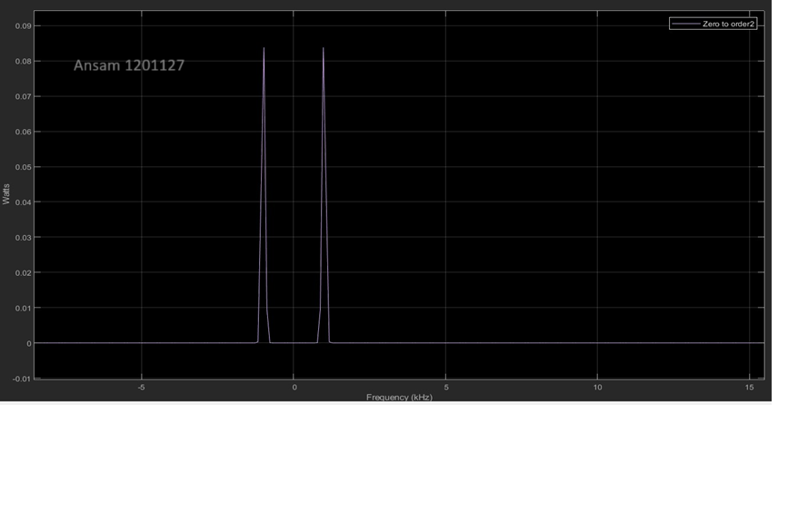

Figure 19:Frequency domain representation of Envelop detection Demodulation when μ <1

When (μ = 1) : Ka = , Am= 0.85

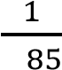0.

Time Domain:

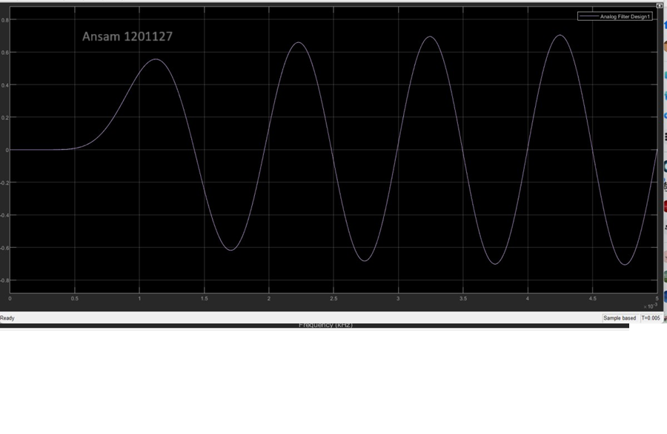

Figure 20:Time domain representation of Envelop detection Demodulation when μ =1

Frequency Domain Representation:

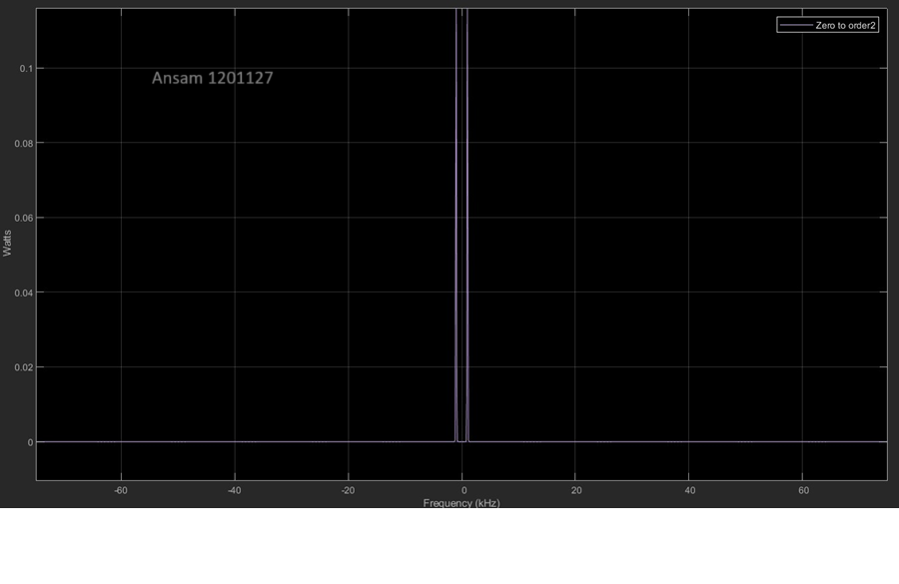

Figure 21: Frequency domain representation of Coherent Demodulation when μ =1

When (μ>1): Ka = 2, Am = 0.85 Time Domain:

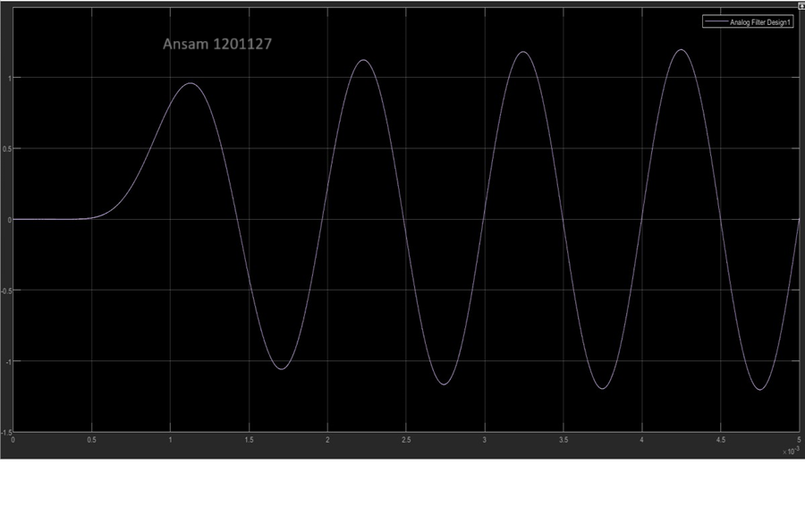

Figure 22Time domain representation of Envelop detection Demodulation when μ >1

Frequency Domain Representation:

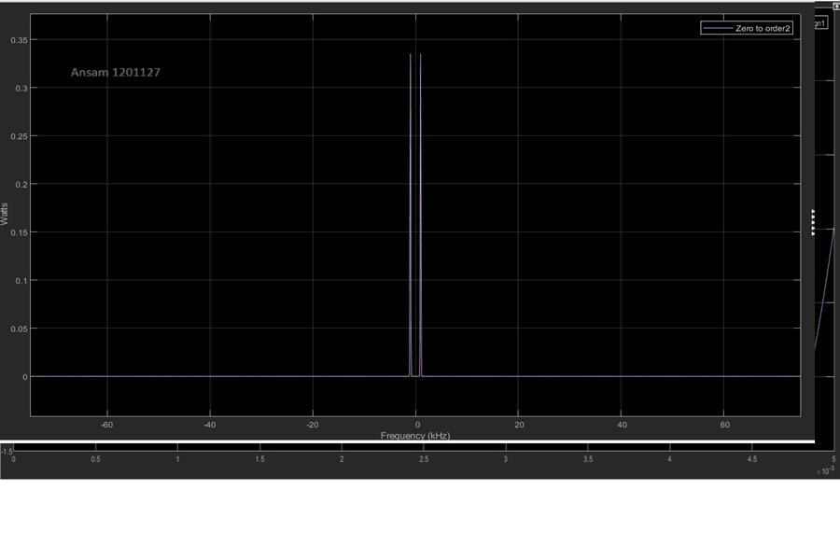

Figure 23:Frequency domain representation of Coherent Demodulation when μ >1

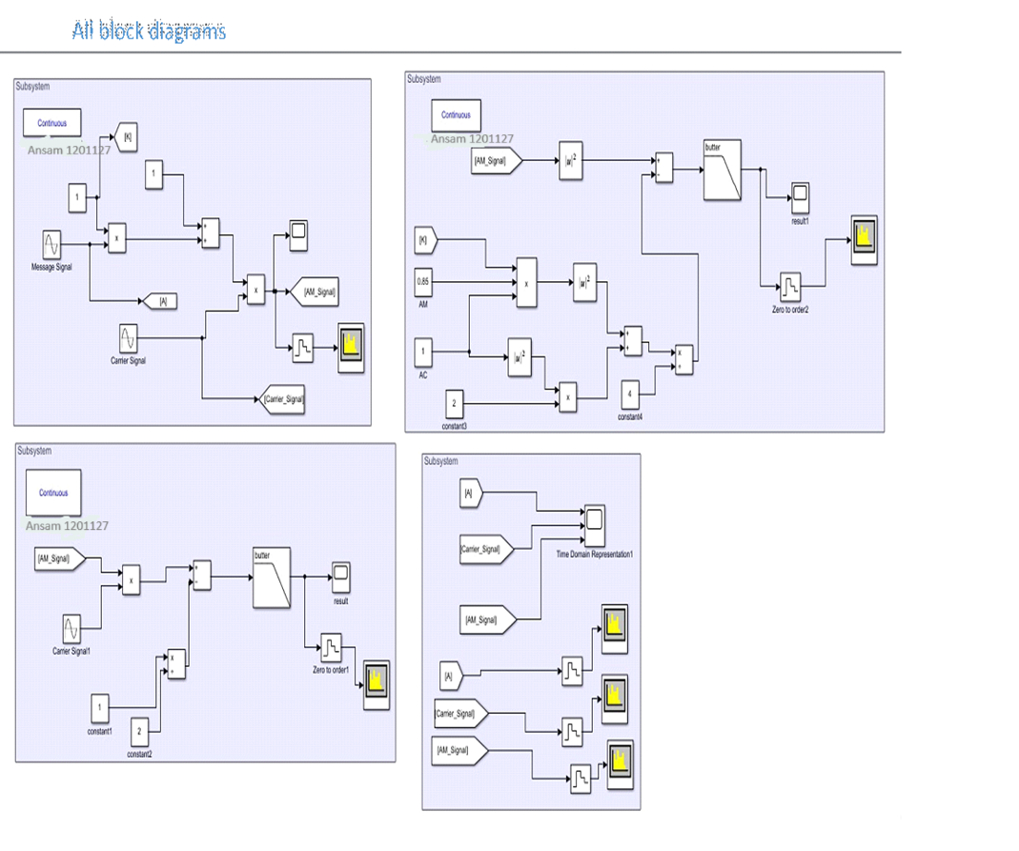



*Figure 26: All Block Diagram*